The first step in most data analytics projects is reading the data file. In this exercise, you’ll create Series and DataFrame objects, both by hand and by reading data files.

# Exercises 1:

In the box below copy the code that creates a DataFrame “fruits” that looks like this:

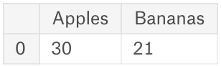

|  |
| --- |
| import pandas as pd  fruits = pd.*DataFrame*({      'Apples': [30],      'Bananas': [21]  })  *print*(fruits) |

# Exercises 2:

In the box below copy the code that creates a DataFrame “fruit_sales” that matches the diagram below:

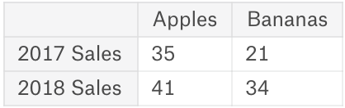

|  |
| --- |
| import pandas as pd  fruit_sales = pd.*DataFrame*({      'Apples': [35, 41],      'Bananas': [21, 34]  }, *index*=['2017 Sales:', '2018 Sales:'])  *print*(fruit_sales) |

# Exercises 3:

Create a variable “ingredients” with a Series that looks like:

Flour 4 cups

Milk 1 cup

Eggs 2 large

Spam 1 can

Name: Dinner, dtype: object

|  |
| --- |
| ingredients = pd.*Series*(['4 cups', '1 cup', '2 large', '1 can'], *index*=['Flour', 'Milk', 'Eggs', 'Spam'], *name*='Dinner')  *print*(ingredients) |

# Exercises 4:

Read the following csv dataset of wine reviews into a DataFrame called “reviews”:

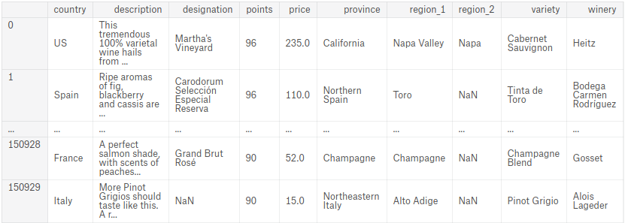

There is a CSV File available for you on Moodle named “wine_reviews”:

|  |
| --- |
| reviews = pd.*read_csv*("Learning Activities\\wine_reviews.csv")  *print*(reviews) |

Create and display the following DataFrame called animals, once created save this DataFrame to disk as a csv file with the name “cows_and_goats.csv”:

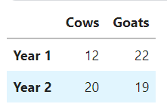

|  |
| --- |
| animals = pd.*DataFrame*({      'Cows': [12, 20],      'Goats': [22, 19]  }, *index*=['Year 1', 'Year 2'])  *print*(animals)  animals.*to_csv*("Learning Activities\\Excercises\\cows_and_goats.csv") |

### Good Job!